Name: K Avinash Reddy
Reg No: 192312463

Experiment 1: Simulation and Comparative Analysis of FDMA, TDMA and CDMA

Objectives
- Model how FDMA, TDMA and CDMA allocate communication resources among users.
- Estimate and compare user capacity under stated assumptions.
- Plot how estimated CDMA SIR changes as the number of simultaneous users increases.
- Relate the access methods to representative mobile generations.

MATLAB Code – Program 1: Capacity and CDMA SIR
clear; clc; close all;
totalBandwidthHz = 1e6; fdmaChannelHz = 200e3; tdmaSlots = 8;
processingGain = 64; targetSIRdB = 7;
fdmaUsers = floor(totalBandwidthHz/fdmaChannelHz);
tdmaUsers = tdmaSlots; targetSIR = 10^(targetSIRdB/10);
cdmaUsers = floor(1 + processingGain/targetSIR);
fprintf('FDMA: %d users\n',fdmaUsers);
fprintf('TDMA: %d users\n',tdmaUsers);
fprintf('CDMA: %d users at target SIR %.1f dB\n',cdmaUsers,targetSIRdB);
K = 2:30; sirDb = 10*log10(processingGain./(K-1));
figure; bar(categorical({'FDMA','TDMA','CDMA'}),[fdmaUsers tdmaUsers cdmaUsers]);
ylabel('Illustrative supported users'); title('FDMA, TDMA and CDMA Capacity'); grid on;
figure; plot(K,sirDb,'o-'); hold on; yline(targetSIRdB,'--r','Target SIR');
xlabel('Simultaneous CDMA users'); ylabel('Estimated SIR (dB)');
title('CDMA SIR versus Number of Users'); grid on; hold off;

MATLAB Code – Program 2: Mobile-Generation Comparison
generation = ["1G";"2G";"2G";"3G";"4G";"5G"];
system = ["AMPS";"GSM";"IS-95";"UMTS";"LTE";"5G NR"];
accessMethod = ["FDMA";"TDMA";"CDMA";"WCDMA";"OFDMA";"OFDMA-based"];
keyIdea = ["Separate frequency channels";"Separate time slots"; ...
"Code-based user separation";"Wideband code-based access"; ...
"Orthogonal frequency resources";"Flexible OFDM-based radio access"];
disp(table(generation,system,accessMethod,keyIdea));

MATLAB Code – Program 3: Resource-Allocation Diagram
% Conceptual resource-allocation figure for FDMA, TDMA and CDMA.
figure; tiledlayout(1,3);
nexttile; barh(1:4,ones(1,4)); title('FDMA: Frequency channels'); xlabel('Time');
nexttile; bar(1:4,ones(1,4)); title('TDMA: Time slots'); xlabel('Time slot');
nexttile; bar(1,ones(1,4)); title('CDMA: Shared band, different codes'); xlabel('Shared band');
sgtitle('Conceptual Resource Allocation');

Output / Graphical Results
Illustrative capacity estimate: FDMA = 5 users, TDMA = 8 users, CDMA = 13 users at a target SIR of 7 dB. These are simplified teaching assumptions, not real network capacity figures.
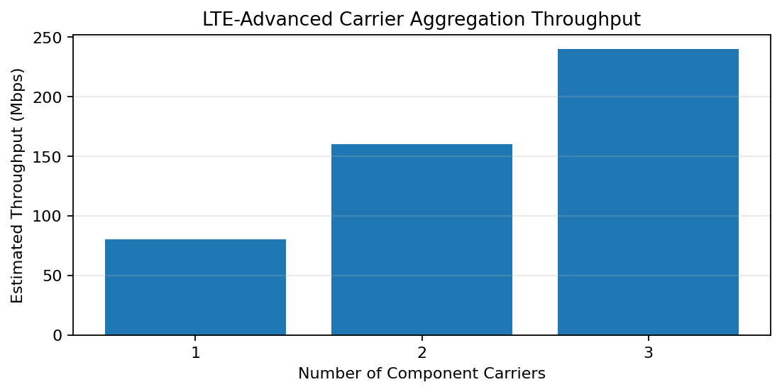
Graph 1. Comparison of illustrative supported users.
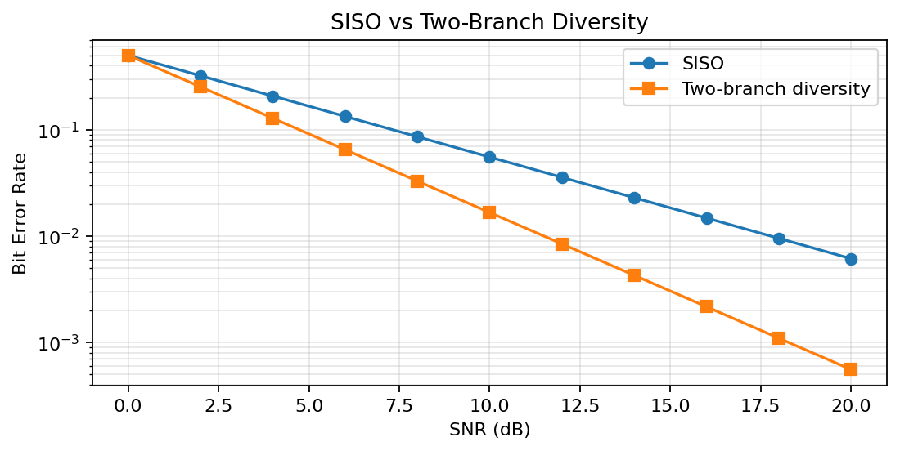
Graph 2. Estimated CDMA SIR decreases as simultaneous users increase.
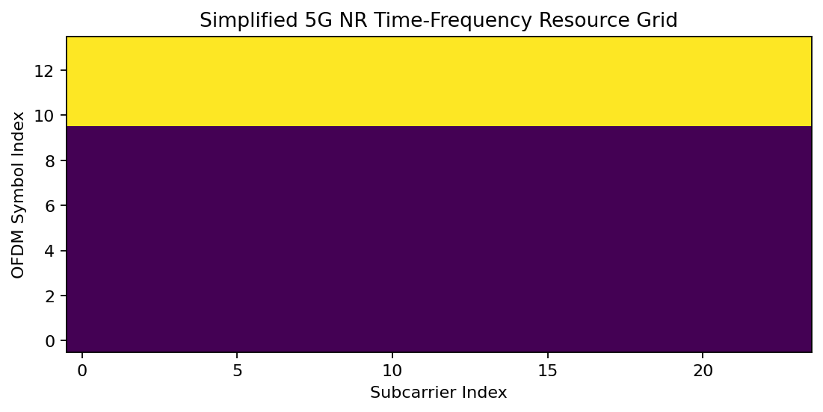
Graph 3. Conceptual resource allocation in FDMA, TDMA and CDMA.

Experiment 2: MATLAB Simulation of Cellular Coverage, Cell Splitting and Handoff

Objectives
- Model adjacent hexagonal cell coverage and identify cell centers and boundaries.
- Estimate the number of cells needed to cover a fixed service area for different cell radii.
- Compare estimated users served under a stated per-cell capacity assumption.
- Simulate a mobile crossing a cell boundary and identify the serving-cell transition.

MATLAB Code
clear; clc; close all;
serviceAreaKm2 = 5; radiiKm = [1.0 0.5]; usersPerCell = 30;
hexArea = @(R) (3*sqrt(3)/2).*R.^2;
cellAreaKm2 = hexArea(radiiKm);
cellCount = ceil(serviceAreaKm2./cellAreaKm2);
estimatedUsers = cellCount.*usersPerCell;
disp(table(radiiKm(:),cellAreaKm2(:),cellCount(:),estimatedUsers(:), ...
'VariableNames',{'Radius_km','CellArea_km2','EstimatedCells','IllustrativeUsers'}));
R = 1; centers = [0 0; 1.5*R sqrt(3)*R/2; 1.5*R -sqrt(3)*R/2; ...
0 sqrt(3)*R; 0 -sqrt(3)*R; -1.5*R sqrt(3)*R/2; -1.5*R -sqrt(3)*R/2];
theta = (0:6)*pi/3; figure; hold on; axis equal; grid on;
for k=1:size(centers,1)
plot(centers(k,1)+R*cos(theta),centers(k,2)+R*sin(theta),'k-');
text(centers(k,1),centers(k,2),sprintf('Cell %d',k),'HorizontalAlignment','center');
end; xlabel('x (km)'); ylabel('y (km)'); title('Seven-Cell Hexagonal Cluster'); hold off;
mobileX = linspace(-0.2*R,1.7*R,300);
d1 = abs(mobileX); d2 = abs(mobileX-1.5*R);
servingCell = ones(size(mobileX)); servingCell(d2<d1)=2;
idx = find(diff(servingCell)~=0,1,'first')+1;
figure; plot(mobileX,d1,mobileX,d2,'LineWidth',1.5); grid on; hold on;
if ~isempty(idx), xline(mobileX(idx),'--r','Handoff'); end
xlabel('Mobile x-position (km)'); ylabel('Distance (km)');
legend('Cell 1','Cell 2'); title('Nearest-Center Handoff'); hold off;
figure; stairs(mobileX,servingCell,'LineWidth',1.5); grid on;
xlabel('Mobile x-position (km)'); ylabel('Serving-cell ID'); title('Serving Cell Along Mobile Path');

Output / Graphical Results
For a 5 km² service area and 30 illustrative users per cell: radius 1.0 km gives about 2 cells and 60 users; radius 0.5 km gives about 8 cells and 240 users. This estimate ignores boundary tiling and real-world planning constraints.
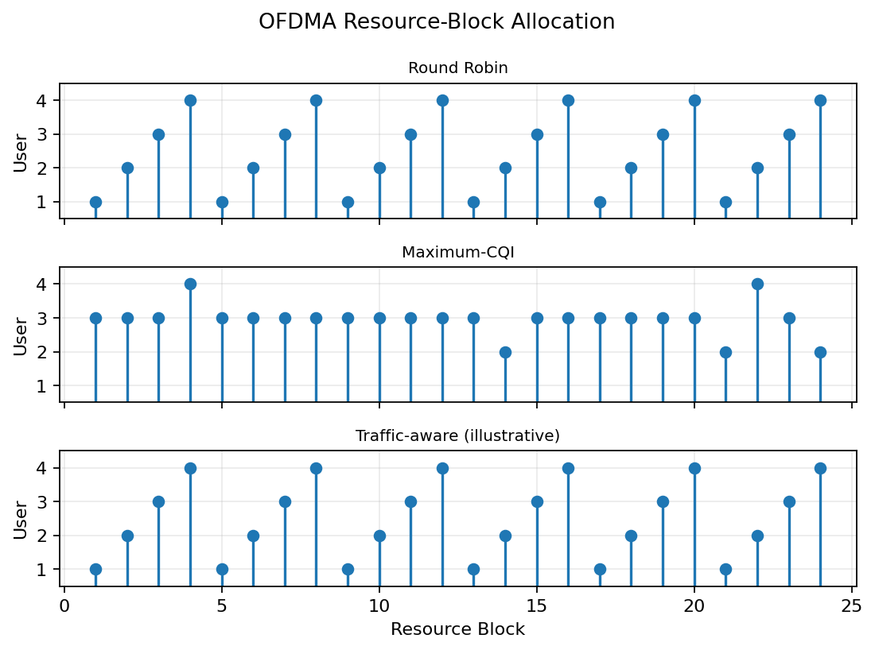
Graph 4. Idealized seven-cell hexagonal cluster.
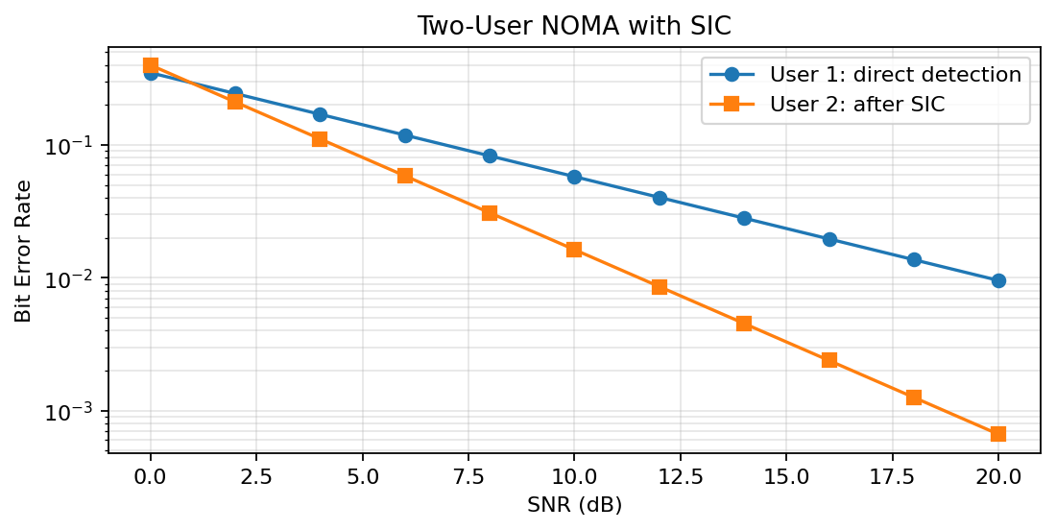
Graph 5. Mobile distance to two cell centers and the approximate handoff point.
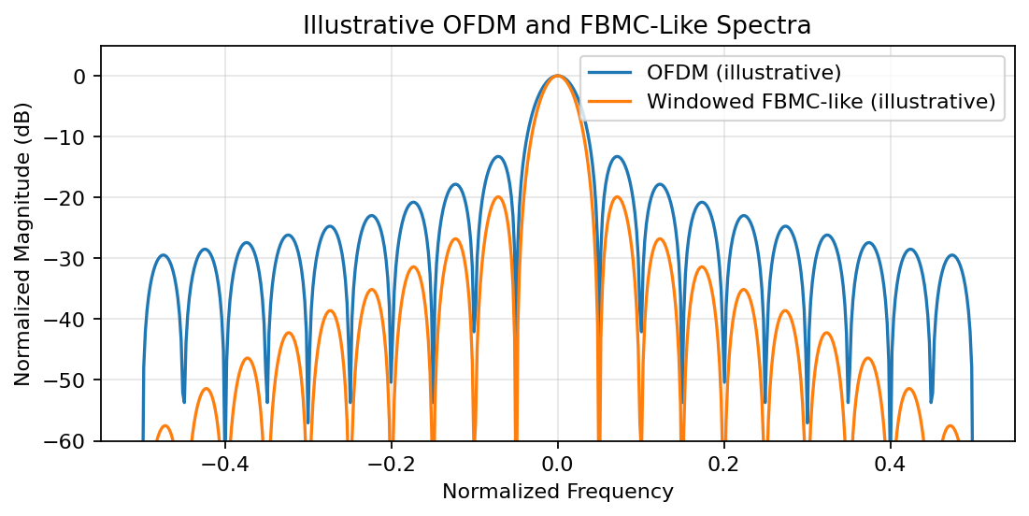
Graph 6. Serving-cell ID along the mobile path.

Experiment 3: MATLAB Analysis of Spectrum Bands, Propagation Loss and Cellular Interference

Objectives
- Compare free-space path loss at representative sub-1 GHz, mid-band and mmWave frequencies.
- Estimate received signal power as frequency and distance change.
- Examine how frequency-reuse cluster size affects a simplified interference ratio.
- Relate the results to coverage and spectrum-use considerations.

MATLAB Code
clear; clc; close all;
freqGHz = [0.7 3.5 28]; freqMHz = freqGHz*1000;
bandName = ["Sub-1 GHz";"Mid-band";"mmWave"];
txPowerdBm = 30; distanceKm = logspace(log10(0.1),log10(2),200);
fspl = @(f,d) 32.44+20*log10(f)+20*log10(d);
d0 = 0.5; loss = fspl(freqMHz,d0); rx = txPowerdBm-loss;
disp(table(bandName,freqGHz(:),loss(:),rx(:), ...
'VariableNames',{'Band','Frequency_GHz','FSPL_dB','EstimatedRx_dBm'}));
figure; hold on; grid on;
for k=1:numel(freqMHz), plot(distanceKm,fspl(freqMHz(k),distanceKm)); end
set(gca,'XScale','log'); xlabel('Distance (km)'); ylabel('Path loss (dB)');
legend(bandName,'Location','northwest'); title('Free-Space Path Loss'); hold off;
figure; hold on; grid on;
for k=1:numel(freqMHz), plot(distanceKm,txPowerdBm-fspl(freqMHz(k),distanceKm)); end
set(gca,'XScale','log'); xlabel('Distance (km)'); ylabel('Received power (dBm)');
legend(bandName,'Location','southwest'); title('Estimated Received Power'); hold off;
cellRadiusKm = 0.5; reuseN = [1 3 7 12]; n = 3.5;
reuseDistance = sqrt(3*reuseN)*cellRadiusKm;
sirDb = 10*log10((reuseDistance/cellRadiusKm).^n/6);
disp(table(reuseN(:),reuseDistance(:),sirDb(:), ...
'VariableNames',{'ReuseClusterN','InterfererDistance_km','ApproxSIR_dB'}));
figure; plot(reuseN,sirDb,'o-'); grid on;
xlabel('Reuse cluster size N'); ylabel('Approximate SIR (dB)');
title('Co-Channel SIR versus Reuse Cluster Size');

Output / Graphical Results
At 0.5 km, the simplified free-space model gives estimated received power of approximately −53.32 dBm at 0.7 GHz, −67.30 dBm at 3.5 GHz and −85.36 dBm at 28 GHz (30 dBm transmit power, 0 dBi antenna gains). Actual cellular propagation differs from free-space loss.
Graph 7. Free-space path loss increases with distance and frequency.
Graph 8. Estimated received power decreases with distance; higher frequency has higher free-space loss.
Graph 9. Simplified co-channel SIR estimate versus reuse cluster size.
Note: Graphs in this document are generated from the simplified MATLAB models described above. Run the MATLAB code to produce corresponding MATLAB figures on your computer.

Experiment 5: LTE-Advanced Carrier Aggregation

Objective
To simulate carrier aggregation and compare estimated throughput when one, two, and three 20 MHz component carriers are combined.

MATLAB Code
clc; clear; close all;
BWcc = 20; % Bandwidth per component carrier (MHz)
SE = 4; % Spectral efficiency (bit/s/Hz)
CC = [1 2 3]; % Number of component carriers
AggBW = BWcc .* CC; % Aggregated bandwidth (MHz)
Throughput = AggBW .* SE; % Estimated throughput (Mbps)
disp(table(CC',AggBW',Throughput', ...
'VariableNames',{'Carriers','Bandwidth_MHz','Throughput_Mbps'}));
figure;
bar(CC,Throughput);
grid on;
xlabel('Number of Component Carriers');
ylabel('Estimated Throughput (Mbps)');
title('LTE-Advanced Carrier Aggregation Throughput');

Output
Figure 5.1: LTE-Advanced Carrier Aggregation — MATLAB-style output
Output: Estimated throughput is 80, 160, and 240 Mbps for one, two, and three component carriers, respectively, using the simplified 4 bit/s/Hz assumption.

Experiment 6: MIMO and Beamforming

Objective
To compare a single-antenna link with a simplified two-branch diversity link using BER versus SNR, and to observe beamforming gain.

MATLAB Code
clc; clear; close all;
rng(4);
SNRdB = 0:2:20;
N = 20000;
BER_SISO = zeros(size(SNRdB));
BER_MRC = zeros(size(SNRdB));
for k = 1:numel(SNRdB)
bits = randi([0 1],N,1);
tx = 2*bits - 1;
g = 10^(SNRdB(k)/10);
noise = randn(N,1)/sqrt(2*g);
rx = tx + noise;
BER_SISO(k) = mean((rx > 0) ~= bits);
h1 = (randn(N,1)+1i*randn(N,1))/sqrt(2);
h2 = (randn(N,1)+1i*randn(N,1))/sqrt(2);
n1 = (randn(N,1)+1i*randn(N,1))/sqrt(2*g);
n2 = (randn(N,1)+1i*randn(N,1))/sqrt(2*g);
y1 = h1.*tx + n1; y2 = h2.*tx + n2;
z = conj(h1).*y1 + conj(h2).*y2;
BER_MRC(k) = mean((real(z) > 0) ~= bits);
end
figure;
semilogy(SNRdB,max(BER_SISO,1/N),'o-','LineWidth',1.5); hold on;
semilogy(SNRdB,max(BER_MRC,1/N),'s-','LineWidth',1.5);
grid on; xlabel('SNR (dB)'); ylabel('Bit Error Rate');
title('SISO vs Two-Branch Diversity (Illustrative MIMO)');
legend('SISO','Two-branch combining','Location','southwest');

Output
Figure 6.1: MIMO and Beamforming — MATLAB-style output
Output: BER generally decreases as SNR increases. Multiple receive branches can improve reliability when diversity combining is correctly implemented.

Experiment 7: 5G NR Frame Structure and Subcarrier Spacing

Objective
To visualize a simplified 5G NR time-frequency resource grid and compare slot duration for different subcarrier spacings.

MATLAB Code
clc; clear; close all;
Nsc = 24; Nsym = 14;
resourceGrid = zeros(Nsym,Nsc);
resourceGrid(1:10,:) = 1; % Simplified downlink symbols
resourceGrid(11:14,:) = 2; % Simplified uplink symbols
figure;
imagesc(resourceGrid);
xlabel('Subcarrier Index'); ylabel('OFDM Symbol Index');
title('Simplified 5G NR Time-Frequency Resource Grid');
colorbar; colormap([0.85 0.85 0.95; 0.3 0.6 0.9]);
figure;
SCS = [15 30 60 120 240]; % kHz
slot_ms = [1 0.5 0.25 0.125 0.0625];
plot(SCS,slot_ms,'o-','LineWidth',1.5);
grid on; xlabel('Subcarrier Spacing (kHz)'); ylabel('Slot Duration (ms)');
title('5G NR Slot Duration vs Subcarrier Spacing');

Output
Figure 7.1: 5G NR Frame Structure and Subcarrier Spacing — MATLAB-style output
Output: The resource grid separates illustrative downlink and uplink symbol regions. Higher subcarrier spacing corresponds to shorter slot duration.

Experiment 9: OFDMA Resource-Block Allocation

Objective
To simulate allocation of 24 orthogonal resource blocks among four users and compare round-robin, maximum-CQI, and traffic-aware scheduling.

MATLAB Code
clc; clear; close all;
rng(7);
K = 4; NRB = 24; BRB = 180e3; Tslot = 1e-3; etaMax = 6;
avgSNRdB = [5 10 15 8]; trafficMbps = [8 12 5 10];
snrDB = avgSNRdB(:) + 4*randn(K,NRB);
eta = min(log2(1 + 10.^(snrDB/10)),etaMax);
rateMbps = BRB .* eta / 1e6;
% Round robin
allocRR = zeros(K,NRB);
for n=1:NRB, allocRR(mod(n-1,K)+1,n)=1; end
% Maximum channel quality
allocCQI = zeros(K,NRB);
for n=1:NRB, [~,u]=max(snrDB(:,n)); allocCQI(u,n)=1; end
% Traffic-aware greedy allocation
allocTA = zeros(K,NRB); served=zeros(K,1);
for n=1:NRB
rem=max(trafficMbps(:)-served,0);
if all(rem<=0), break; end
metric=rateMbps(:,n).*rem./max(trafficMbps(:),eps);
metric(rem<=0)=-inf;
[~,u]=max(metric); allocTA(u,n)=1;
served(u)=served(u)+rateMbps(u,n);
end
A = cat(3,allocRR,allocCQI,allocTA);
names = {'Round Robin','Max-CQI','Traffic-aware'};
figure;
for s=1:3
subplot(3,1,s); [u,n]=find(A(:,:,s));
stem(n,u,'filled'); grid on; ylim([0.5 K+0.5]);
xlabel('Resource Block'); ylabel('User'); title(names{s});
end

Output
Figure 9.1: OFDMA Resource-Block Allocation — MATLAB-style output
Output: The allocation map shows one scheduled user per resource block. Round-robin distributes resources evenly; maximum-CQI favors stronger instantaneous channels; traffic-aware scheduling also considers remaining demand.

Experiment 10: NOMA and Successive Interference Cancellation

Objective
To model a two-user power-domain NOMA signal and illustrate receiver detection with successive interference cancellation (SIC).

MATLAB Code
clc; clear; close all;
rng(10);
N = 50000; SNRdB = 0:2:20;
alpha1 = 0.75; alpha2 = 1-alpha1;
berFar = zeros(size(SNRdB)); berNear = zeros(size(SNRdB));
for k=1:numel(SNRdB)
b1=randi([0 1],N,1); b2=randi([0 1],N,1);
x1=2*b1-1; x2=2*b2-1;
snrLin=10^(SNRdB(k)/10);
noise=randn(N,1)/sqrt(2*snrLin);
y=sqrt(alpha1)*x1 + sqrt(alpha2)*x2 + noise;
d1=y>0; x1hat=2*d1-1;
ySIC=y-sqrt(alpha1)*x1hat;
d2=ySIC>0;
berFar(k)=mean(d1~=b1);
berNear(k)=mean(d2~=b2);
end
figure;
semilogy(SNRdB,max(berFar,1/N),'o-','LineWidth',1.5); hold on;
semilogy(SNRdB,max(berNear,1/N),'s-','LineWidth',1.5);
grid on; xlabel('SNR (dB)'); ylabel('Bit Error Rate');
title('Two-User NOMA with Successive Interference Cancellation');
legend('User 1: direct detection','User 2: after SIC','Location','southwest');

Output
Figure 10.1: NOMA and Successive Interference Cancellation — MATLAB-style output
Output: The BER curves illustrate how error performance changes with SNR and receiver processing. Actual results depend on power allocation, channel assumptions, and SIC error propagation.

Experiment 11: OFDM and FBMC Wireless Waveforms

Objective
To compare illustrative frequency-domain spectra of an OFDM waveform and a windowed FBMC-like waveform, focusing on out-of-band emissions.

MATLAB Code
clc; clear; close all;
N = 256; M = 64; % Number of subcarriers and samples
n = 0:M-1; k = 0:N-1;
% Simplified OFDM waveform: sum of orthogonal subcarriers
X = zeros(1,N); X(1:16) = 1;
ofdm = ifft(X,N);
% Simplified FBMC-like pulse shaping illustration
win = hann(N).';
fbmc = ifft(X,N).*win;
f = linspace(-0.5,0.5,N);
OFDMspec = abs(fftshift(fft(ofdm,N))); OFDMspec = OFDMspec/max(OFDMspec);
FBMCspec = abs(fftshift(fft(fbmc,N))); FBMCspec = FBMCspec/max(FBMCspec);
figure;
plot(f,20*log10(OFDMspec+1e-6),'LineWidth',1.5); hold on;
plot(f,20*log10(FBMCspec+1e-6),'LineWidth',1.5);
grid on; xlabel('Normalized Frequency'); ylabel('Normalized Magnitude (dB)');
title('Illustrative OFDM and Windowed Waveform Spectra');
legend('OFDM','Windowed FBMC-like','Location','southwest');

Output
Figure 11.1: OFDM and FBMC Wireless Waveforms — MATLAB-style output
Output: The illustrative plot compares spectral confinement. This simplified windowed waveform is for conceptual comparison and is not a standards-compliant FBMC implementation.

